
Global Quest Technologies

PROJECT REPORT ON
“PORTFOLIO”
Using front end technologies
Submitted by
NAMRATHA M
(GQT-S0039)
Under the esteemed guidance of
KESHAV MURTHY
(FRONTEND Trainer at GQT)

________________ ___________________
Signature of Trainer Signature of CEO (GQT)
KESHAV NARENDRA REDDY
Date: Date:

INTRODUCTION
PORTFOLIO

Scope of the document:

Welcome to my personal portfolio website!
This website is a reflection of my journey, my passion, and my commitment to frontend development. It's a virtual canvas where I showcase my work, share my experiences, and connect with individuals who appreciate creativity and innovation.
As a web developer, “I've had the privilege of working on a wide range of projects, from building interactive e-commerce websites to developing custom web applications for businesses, which have not only sharpened my coding skills but also enhanced the user experience and functionality of various online platforms". This website is a testament to the countless hours of dedication, learning, and exploration that have brought me to where I am today.
Through these digital pages, you'll find a curate selection of my projects, each representing a piece of my creative vision and expertise. From designing responsive and user-friendly interfaces to optimizing website performance and implementing robust security measures, my work showcases a holistic approach to web development that emphasizes both aesthetics and functionality; I've poured my heart and soul into every endeavour.
I've designed this website not only to showcase my work but also to connect with like-minded individuals, potential collaborators, and anyone who shares a passion for frontend design. Whether you're here to explore my portfolio, discuss a potential project, or simply get in touch, I'm thrilled to have you as a visitor.
Thank you for taking the time to explore my online space. I hope you find inspiration within these virtual walls, and I look forward to the possibility of collaborating and creating something incredible together.

ROOT STRUCTURE

PPIS WEBSITE →CODES
→HTML Files
→Home.html
→About .html
→Education.html
→Experience.html
→Skills.html
→Contact.html
→Read More.html

→CSS Files
→Home.css
PROJECT REPORT
→FRONT END PROJECT PORTFOLIO.DOC
SCREENSHOTS
→ALL THE CORRESPONDING SCREENSHOTS OF PAGES

FILE HIERARCHY DIAGRAM
Portfolio (clone)
Home

hh
Home.html

hh
Home.css

hh
About

hh
About.css

hh
About .html

hh
Education
hh
Education.css

hh
Education.html

hh
Experience

hh
Experience.css

hh
Experience.html

hh
Skills

hh
Skills.css

hh
Skills.html

hh
Contact

hh
Oil and Gases.css

hh
Contact.html

hh
Read More
hh
Read More.html

hh
Read More.css

hh

HISTORY OF HTML:
HTML stands for Hyper Text Markup Language.
- It is used to share the information over the internet.
- HTML id developed by Tim Berner’s Lee in 1991.But officially in 1993.
- The First version of HTML consists of “18 tags”
- HTML follows certain rules and regulations setup by “ISO”.
- International Organization for standardization is set of rules and regulation are present in ‘SGML’ document.

Versions of HTML
- HTML-1 version in the year 1993.
- Html-2 version in the year 1995.
- HTML-3.02 version in the year 1997.
- HTML-4.1 version in the year 1999.
- HTML-5 version in the year 2014.

Features of HTML
- It is easy to Learn.
- It is a tag based language.
- HTML is supported by multiple browsers.
- First web browser is Netscape navigation which was developed by the “Mosiac”.
- It is a portable language.
- WORA stands for ‘write once run anywhere’

Limitation of HTML
- HTML has less designing capabilities.
- It is dependent on other technology such as CSS in order to develop well designed Webpages.
- HTML has no programming capabilities.
- Using HTML and CSS we can develop only static Web page. In order to write the HTML code required an editor such as VS Code, Notepad, Eclipse.
- In order to execute the HTML code we required Web browsers.Like Chrome, Firefox, edge, Opera Safari .

CSS
- CSS stands for Cascading Style Sheets.
- It was developed by W3C to add stylings to the HTML elements.
- W3C stands for World Wide Web.com
Versions of CSS:
- CSS-1 (level-1) in the year 1996.
- CSS-2 (level-2) in the year 1998.
- CSS-3 (level-3) in the year 1999.
Why do we require CSS?
- Since HTML has less designing capabilities we cannot create well designed or most appealing Websites.
- Using HTML we cannot add style, animation and transitions to the Webpage.
- Therefore we require CSS to create well designed WebPages.
Advantages of CSS
- It allows to add styles, animation and various effects to the Webpage.
- It allows us to develop the Webpage rapidly. It is also know as RAD ( rapid application Developer).
- It allows us to separate from formatting develop page to the presentation of Webpage.
- It allows to create well designed Websites.
Limitations of CSS
- Using CSS we can perform static styles for the WebPages.
- In order to create dynamic styling for the Websites. We must make use of scripting language such as JavaScript and Libraries of JavaScript.
Types of CSS:
- Inline CSS
- Internal CSS
- External CSS
- Default Browser CSS
Inline CSS:
Defining all the CSS properties within the style attribute inside the opening of the tag is referred to as Inline CSS.
Internal CSS:
Defining all the CSS properties within <style> inside the HTML document is referred to as Internal CSS.
External CSS:
Defining all the CSS properties within as external Script or File with an extension CSS is referred to as External CSS.
- In order to link external CSS file within the HTML document we must use of <link>.
- The value for the ‘ref’ attribute should be ‘style sheet’.

Our Project
Source Code:-
Home.HTML
<!DOCTYPE html>
<html lang="en">
<head>
<meta charset="UTF-8">
<meta http-equiv="X-UA-Compatible" content="IE=edge">
<meta name="viewport" content="width=device-width, initial-scale=1.0">
<title>Portfolio Website Design-home</title>
<!-- css file -->
<link rel="stylesheet" href="home.css">
<link href='https://unpkg.com/boxicons@2.1.4/css/boxicons.min.css' rel='stylesheet'>
</head>
<body>
<header class="header">
<a href="#" class="logo">Namratha.</a>
<nav class="navbar">
<a href="#home.html" class="active">Home</a>
<a href="About.html" target="_blank">About</a>
<a href="education.html" target="_blank">Education</a>
<a href="experience.html" target="_blank">Experience</a>
<a href="skils.html" target="_blank">Skills</a>
<a href="contact.html" target="_blank">Contact</a>
</nav>
</header>
<!--Home section starts from here-->
<section class="home">
<div class="home-content">
<h1>Hi, I'm Namratha M</h1>
<h3>Frontend Developer</h3>
<p> A passionate frontend developer with a love for crafting user-friendly and visually appealing web experiences. I thrive on turning innovative ideas into reality through the magic of code.</p>
<div class="btn-box">
<!-- <a href="resume.html" target="_blank">Hire Me</a>-->
<a href="contact.html" target="_blank">Let's Talk</a>
</div>
</div>
<div class="home-sci">
<a href="https://www.facebook.com/" target="_blank"><i class='bx bxl-facebook' ></i></a>
<a href="https://twitter.com/i/flow/login?input_flow_data=%7B%22requested_variant%22%3A%22eyJsYW5nIjoiZW4ifQ%3D%3D%22%7D" target="_blank"><i class='bx bxl-twitter' ></i></a>
<a href="https://www.linkedin.com/feed/" target="_blank"><i class='bx bxl-linkedin' ></i></a>
</div>
</section>
<!--section ends here-->
<!--image-->
<div class="class1">
<img src="photo.jpg" style=" transform: perspective(100px) rotate(315deg);
background-image: url(image.jpg);
background-size: cover; height: 550px;
width: 160%;margin-left: 80PX; margin-top: -150px;margin-left: -150px;box-shadow: 4px 4px 8px rgba(red, green, blue, alpha); " alt="">
</div>
</body>
</html>
Home.CSS

*{
margin: 0px;
padding:0px;
box-sizing: border-box;
font-family:sans-serif;
}
body{
background:rgb(8, 8, 59);
color: white;
}
.header{
position: fixed;
top:0px;
left:0px;
width:100%;
padding: 20px 10%;
background-color: transparent;
display: flex;
justify-content: space-between;
align-items: center;
z-index:100;
}
.logo{
font-size:25px;
color:white;
text-decoration: none;
font-weight: 600;
}
.navbar a {
font-size: 18px;
color:white;
text-decoration: none;
font-weight: 500;
margin-left: 35px;
}
.navbar a:hover,
.navbar a.active{
color: rgb(0, 128, 255);
}
.home {
height: 100vh;
display: flex;
align-items: center;
padding: 0 10%;
}
.home-content {
background: transparent;
max-width: 550px;
}
.home-content h1{
font-size: 56px;
font-weight: 700;
line-height: 1.3;
}
.home-content h3{
font-size: 32px;
font-weight: 700;
color:rgb(0, 136, 255);
}
.home-content p{
font-size: 16px;
margin: 20px 0 40px;
line-height: 1.5;
background-color: transparent;
}
.home-content .btn-box {
display: flex;
justify-content: space-between;
width: 345px;
height: 50px;
}
.btn-box a {
position: relative;
display: inline-flex;
justify-content: center;
align-items: center;
width: 150px;
height: 75%;
background: rgb(0, 110, 255);
border:2px solid rgb(0, 110, 255);
border-radius: 8px;
color: black;
text-decoration: none;
font-weight: 600;
letter-spacing: 1px;
z-index: 1;
overflow: hidden;
transition: .5px;
}
.btn-box a:hover {
color:rgb(0, 110, 255);
}
.btn-box a:nth-child(2) {
background: transparent;
color: rgb(0, 110, 255);
}
.btn-box a:nth-child(2):hover{
color: black;
}
.btn-box a:nth-child(2)::before {
background:rgb(0, 110, 255);
}
.btn-box a::before {
content: '' ;
position: absolute;
top: 0;
left: 0;
width: 0;
height: 100%;
background: rgb(8, 8, 59);
z-index: -1;
transition: .5s;
}
.btn-box a:hover:before{
width: 100%;
}
.home-sci{
position: absolute;
bottom: 40px;
width: 170px;
display: flex;
justify-content: space-between;
}
.home-sci a{
position: relative;
display: inline-flex;
justify-content: center;
align-items: center;
width:40px;
height: 40px;
background: transparent;
border:2px solid rgb(0, 110, 255);
border-radius: 50%;
color: rgb(0, 110, 255);
text-decoration: none;
z-index: 1;
overflow: hidden;
}
.home-sci a:hover{
color: black;
}
.home-sci a::before{
content: '';
position: absolute;
top: 0;
left: 0;
width: 0;
height: 100%;
background: rgb(0, 110, 255);
z-index: -1;
transition: .5s;
}
.home-sci a:hover::before{
width: 100%;
}
.class1{
margin-left: 830px;
margin-top: -400px;
border: 0px solid red;
height: 300px;
width: 25%;
transform: perspective(100px) rotate(45deg);
overflow: hidden;
border-radius: 20px;
box-shadow: 9px 10px 5px rgba(0, 72, 255, 0.5);;
box-shadow: -9px 15px 10px rgba(0, 162, 255, 0.5);
box-shadow: 8px 10px -10px rgba(0, 162, 255, 0.5);
}
Output:

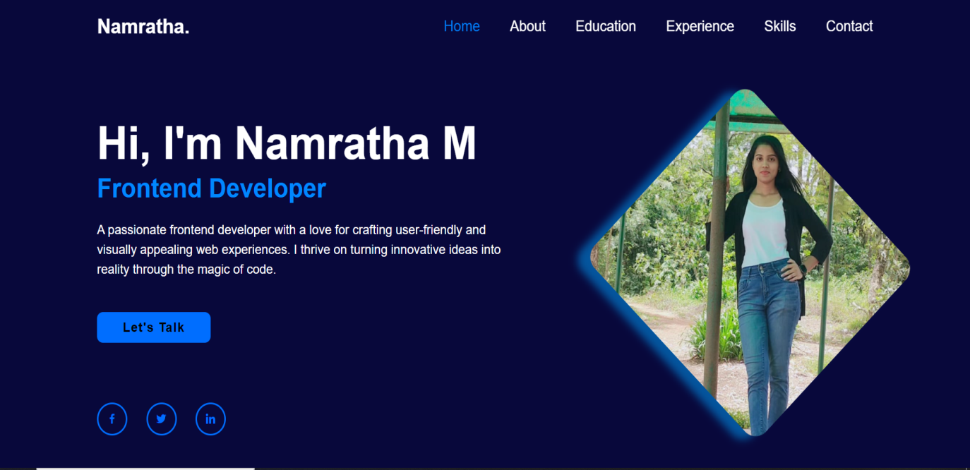
Fig.:1.1

About.HTML/ Inline CSS

<!DOCTYPE html>
<html lang="en">
<head>
<meta charset="UTF-8">
<meta http-equiv="X-UA-Compatible" content="IE=edge">
<meta name="viewport" content="width=device-width, initial-scale=1.0">
<title>Aboout ME</title>
<style>
*{
margin: 0px;
padding:0px;
box-sizing: border-box;
font-family:sans-serif;
}
body{
color: white;
}
.header{
position: fixed;
top:0px;
left:0px;
width:100%;
padding: 20px 10%;
display: flex;
justify-content: space-between;
align-items: center;
z-index:100;
background:rgb(8, 8, 59);
}
.logo{
font-size:25px;
color:white;
text-decoration: none;
font-weight: 600;
}
.navbar a {
font-size: 18px;
color:white;
text-decoration: none;
font-weight: 500;
margin-left: 35px;
}
.navbar a:hover,
.navbar a.active{
color: rgb(0, 128, 255);
}
.section{
height: 100vh;
display: flex;
align-items: center;
background: rgb(16, 16, 83);
}
.about{
border: 0px solid white;
align-items: center;
margin-top: -350px;
margin-left: 42%;
font-size: 20px;
}
.about span{
color: rgb(33, 132, 213);
}
.image{
border: 3px solid rgb(0, 128, 255);
height: 170px;
width: 13%;
margin-left: -13%;
margin-top: -90px;
border-radius: 50%;
background-image: url(pic.jpeg);
background-size: cover;
box-shadow: 4px 4px 6px rgba(38, 80, 148, 0.5);;
}
.div{
border: 0px solid white;
height: 221px ;
width: 85%;
margin-top: 330px;
margin-left: -48%;
}
.div h3{
align-content: center;
text-align: center;
font-size: 20px;
}
div p{
line-height: 30px;
min-height: 30px;
text-align: center;
padding: 20px;
}
.btn-box a {
position: relative;
display: inline-flex;
justify-content: center;
align-items: center;
width: 130px;
height: 35px;
background: rgb(0, 110, 255);
border:2px solid rgb(0, 110, 255);
border-radius: 8px;
color: black;
text-decoration: none;
font-weight: 600;
letter-spacing: 1px;
z-index: 1;
overflow: hidden;
transition: .5px;
margin-left: 43%;
margin-top: -6px;
}
.btn-box a:hover {
color:rgb(0, 110, 255);
}
.btn-box a:nth-child(2) {
background: transparent;
color: rgb(0, 110, 255);
}
.btn-box a:nth-child(2):hover{
color: black;
}
.btn-box a:nth-child(2)::before {
background:rgb(0, 110, 255);
}
.btn-box a::before {
content: '' ;
position: absolute;
top: 0;
left: 0;
width: 0;
height: 100%;
background: rgb(8, 8, 59);
z-index: -1;
transition: .5s;
}
.btn-box a:hover:before{
width: 100%;
}
</style>
</head>
<body>
<header class="header">
<a href="#" class="logo">Namratha.</a>
<nav class="navbar">
<a href="home.html" target="_blank" >Home</a>
<a href="#About.html" class="active">About</a>
<a href="education.html" target="_blank">Education</a>
<a href="experience.html" target="_blank">Experience</a>
<a href="skill.html" target="_blank">Skills</a>
<a href="contact.html" target="_blank">Contact</a>
</nav>
</header>
<div class="section">
<div class="about">
<h1>About <span>Me</span></h1>
</div>
<div class="image">
</div>
<div class="div">
<h3>Frontend Developer.!</h3>
<p>"As an accomplished frontend developer, my objective is to leverage my expertise in HTML, CSS, JavaScript, and responsive design to create visually stunning and highly functional web applications. I am dedicated to crafting seamless user experiences and ensuring optimal performance across various devices. With a passion for staying updated on emerging technologies, I aim to contribute my skills and creativity to drive innovation and enhance user engagement within a collaborative development team."</p>
<div class="btn-box">
<a href="readmore.html" target="_blank">Read More</a>
</div>
</div>
</div>
</body>
</html>

Output:

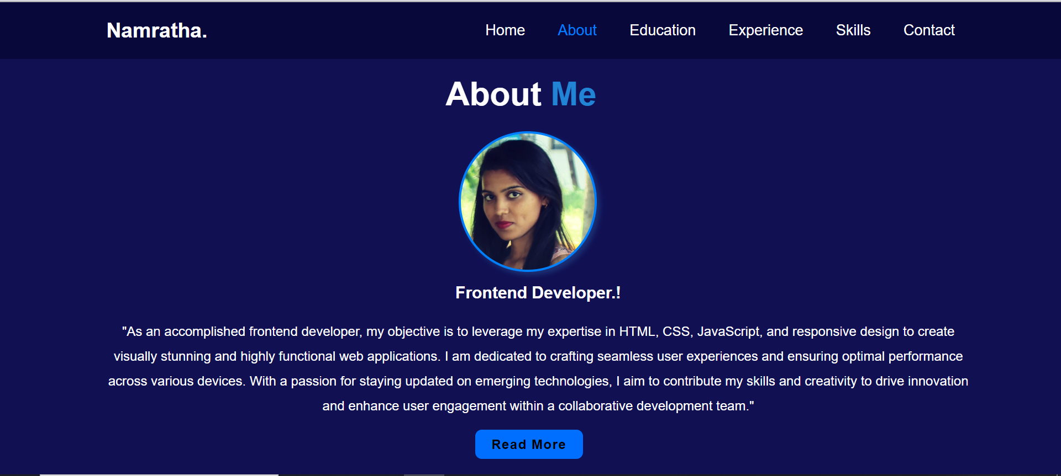
Fig.:2.1

About - Read More.HTML/ Inline CSS (latest projects)

<!DOCTYPE html>
<html lang="en">
<head>
<meta charset="UTF-8">
<meta http-equiv="X-UA-Compatible" content="IE=edge">
<meta name="viewport" content="width=device-width, initial-scale=1.0">
<title>Read more</title>
<style>
*{
margin: 0px;
padding: 0px;
}
.whole{
background-color:rgb(8, 8, 59);
height: 550px;
border:1px solid rgb(8, 8, 59); ;
}
h2{
background: transparent;
color: white;
width: 20%;
text-align: center;
margin-left: 550px;
margin-top: 30px;
}

h2 span{
color: rgb(0, 128, 255);
}

.div1{
width: 18%;
height: 170px;
background: aliceblue;
margin-left: 185px;
margin-top: 65px;
background: url(https://lockeys.in/project-center-in-chennai/VLSI-courses-in-chennai.jpg); background-size: cover;border-radius: 20px;
}
.div1:hover{
transform: scale(1.1);
transition-property: transform;
transition-duration: .1s,.1s,.1s;
transition-timing-function: linear, linear, linear;
transition-delay: .1s,.1s,.1s;
box-shadow: -2px 4px 2px rgb(0, 128, 255);
}
.div2{
width: 18%;
height: 170px;
background: aliceblue;
margin-left: 186px;
margin-top: 35px;
background: url(https://techposts.org/wp-content/uploads/2017/11/ESP8266-NodeMCU-Module.jpg);background-size: cover; border-radius: 20px;
}
.div2:hover{
transform: scale(1.1);
transition-property: transform;
transition-duration: .1s,.1s,.1s;
transition-timing-function: linear, linear, linear;
transition-delay: .1s,.1s,.1s;
box-shadow: -2px 4px 2px rgb(0, 128, 255);;
}
.div3{
width: 18%;
height: 170px;
background: aliceblue;
margin-left: 525px;
margin-top: -360px;
background: url(https://www.creative-tim.com/blog/content/images/2022/01/which-development-job-is-right-for-you.jpg); background-size: cover;
border-radius: 20px;
}
.div3:hover{
transform: scale(1.1);
transition-property: transform;
transition-duration: .1s,.1s,.1s;
transition-timing-function: linear, linear, linear;
transition-delay: .1s,.1s,.1s;
box-shadow: -2px 4px 2px rgb(0, 128, 255);;
}
.div4{
width: 18%;
height: 170px;
background: aliceblue;
margin-left: 526px;
margin-top: 40px;
background: url(https://encrypted-tbn0.gstatic.com/images?q=tbn:ANd9GcR93RWMTP5yA8EZLP0b1KjcrUTqVJn1Dyxz5Q&usqp=CAU);background-size: cover;border-radius: 20px;
}
.div4:hover{
transform: scale(1.1);
transition-property: transform;
transition-duration: .1s,.1s,.1s;
transition-timing-function: linear, linear, linear;
transition-delay: .1s,.1s,.1s;
box-shadow: -2px 4px 2px rgb(0, 128, 255);;
}
.div5{
width: 18%;
height: 170px;
background: aliceblue;
margin-left: 850px;
margin-top: -396px;
background: url(https://knackforge.com/wp-content/uploads/2022/10/12979913_5078151-scaled.jpg);background-size: cover; border-radius: 20px;
}
.div5:hover{
transform: scale(1.1);
transition-property: transform;
transition-duration: .1s,.1s,.1s;
transition-timing-function: linear, linear, linear;
transition-delay: .1s,.1s,.1s;
box-shadow: -2px 4px 2px rgb(0, 128, 255);;
}
.div6{
width: 18%;
height: 170px;
background: aliceblue;
margin-left: 850px;
margin-top: 40px;
background: url(https://asapkerala.gov.in/wp-content/uploads/2021/10/AI-Tester.jpg);background-size: cover;border-radius: 20px;
}
.div6:hover{
transform: scale(1.1);
transition-property: transform;
transition-duration: .1s,.1s,.1s;
transition-timing-function: linear, linear, linear;
transition-delay: .1s,.1s,.1s;
box-shadow: -2px 4px 2px rgb(0, 128, 255);;
}
h1{
color: white;
text-align: center;
font-size: 20px;
}
p{
color: transparent;
background:transparent;
margin-top: 10px;
border: 0px solid red;
}
p:hover{
color: white;
background-color: transparent;
font-size: 15px;
text-align: center;
}
</style>
</head>
<body>
<div class="whole">
<div>
<h2>LATEST <span>PROJECTS</span></h2>
<div class="div1"><div><h1>VLSI</h1><p>Internship at PLUS PPA Nanochip Technologies Private Limited, Bangalore:
PMOS, NMOS, INVERTER, NAND, NOR, Inverter analysis, SRAM basics Design and Analysis of bit cell operation.</p></div></div>
<div class="div2"><h1>Nodemcu ESP8266</h1><p>An RFID-based attendance system using NodeMCU is a streamlined solution that employs RFID technology and NodeMCU to automate attendance tracking in settings like schools or workplaces.</p></div>
<div class="div3"><h1>Web Developer</h1><p>A web developer is a skilled professional who creates and maintains websites, using coding languages like HTML, CSS, and JavaScript. They ensure websites are visually appealing, functional, and user-friendly.</p></div>
<div class="div4"> <h1>CHIP DESIGN</h1><p>Internship at maven silicon on VLSI System on chip Design, Bangalore (01/2023 - 07/2023)<br>Chip design is a process of designing a chip and is an essential part of electronics engineering.</p></div>
<div class="div5"><h1>Embedded System Design</h1><p>Embedded system design creates specialized computer systems for devices, with real-time constraints and resource limitations, requiring hardware and software integration expertise for applications like consumer electronics and automotive control systems.</p> </div>
<div class="div6"><h1>Full Stack Developer</h1><p>A full-stack developer is a multifaceted professional skilled in both front-end and back-end web development, capable of handling all aspects of web application creation, from design to server management.</p> </div>
</div>
</div>
</body>
</html>

Output:

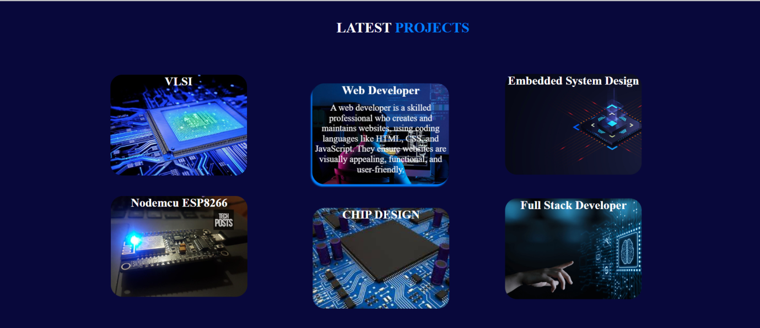
Fig.:2.1.1

Education.HTML/ Inline CSS
<!DOCTYPE html>
<html lang="en">
<head>
<meta charset="UTF-8">
<meta http-equiv="X-UA-Compatible" content="IE=edge">
<meta name="viewport" content="width=device-width, initial-scale=1.0">
<title>education</title>
<link href='https://unpkg.com/boxicons@2.1.4/css/boxicons.min.css' rel='stylesheet'>
<style>
*{
margin: 0px;
padding:0px;
box-sizing: border-box;
font-family:sans-serif;
}
body{
color: white;
}
.header{
position: fixed;
top:0px;
left:0px;
width:100%;
padding: 20px 10%;
display: flex;
justify-content: space-between;
align-items: center;
z-index:100;
background:rgb(8, 8, 59);
}
.logo{
font-size:25px;
color:white;
text-decoration: none;
font-weight: 600;
}
.navbar a {
font-size: 18px;
color:white;
text-decoration: none;
font-weight: 500;
margin-left: 35px;
}
.navbar a:hover,
.navbar a.active{
color: rgb(0, 128, 255);
}
.section{
height: 100vh;
display: flex;
align-items: center;
background: rgb(16, 16, 83);
}
.skills{
border: 0px solid white;
align-items: center;
margin-top: -350px;
margin-left: 42%;
font-size: 20px;
width: 25%;
}
.skills span{
color: rgb(33, 132, 213);
}
.d1{
width:75%;
height: 150px;
border:0px solid rgb(33, 132, 213);
margin-left: -700px;
margin-top: -50px;
border-radius: 20px;box-shadow: 4px -4px 4px white;
}
.d1 div{
width: 25%;
height: 150px;
border: 0px solid white;
border-radius: 20px;
background:url(https://encrypted-tbn0.gstatic.com/images?q=tbn:ANd9GcRH_neXfza999nmNeAclWS8UBuYkcm7XNC9TudLpw0Dh-yqBAE_MMkWY-vRcRcJixCpk_A&usqp=CAU);background-size: cover;background-position: center;box-shadow: 4px 4px 4px;
}
.d2{
width:75%;
height: 150px;
border: 0px solid rgb(33, 132, 213);
margin-top: 290px;
margin-left: -956px;border-radius: 20px;box-shadow: -4px 4px 4px white;
}
.d2 div{
width:25%;
height: 150px;
border: 0px solid white;
float: right;
background: url(https://pbs.twimg.com/ext_tw_video_thumb/1218979342161711106/pu/img/V3ZlIejO8UVdNAEt.jpg:large);background-size: cover;background-position: center;border-radius:20px;box-shadow: 4px 4px 4px;
}
p{
font-size: 15px;
color: white;
width: 70%;
margin-left: 280px;
margin-top: -130px;
line-height: 25px;
font-family:Georgia, 'Times New Roman', Times, serif;
font-size: medium;
letter-spacing: 0.5px;
}
p span{
color: rgb(33, 132, 213);
font-size: 20px;
font-weight: 900;
font-family: sans-serif;
line-height: 10px;
}
h2{
font-size: 15px;
color: white;
width: 70%;
margin-left: 10px;
margin-top: 40px;
line-height: 25px;
font-family:sans-serif;
font-size: medium;
letter-spacing: 0.5px;
}
h2 span{
color: rgb(33, 132, 213);
font-size: 20px;
font-weight: 900;
font-family: sans-serif;
line-height: 10px;
}
</style>
</head>
<body>
<header class="header">
<a href="#" class="logo">Namratha.</a>
<nav class="navbar">
<a href="home.html" target="_blank" >Home</a>
<a href="About.html" target="_blank">About</a>
<a href="#education.html" class="active">Education</a>
<a href="experience.html" target="_blank">Experience</a>
<a href="skill.html" target="_blank">Skills</a>
<a href="contact.html" target="_blank">Contact</a>
</nav>
</header>
<div class="section">
<div class="skills">
<h1>My <span>Educations</span></h1>
</div>
<div class="d1"> <div></div><p><span>B.E in Electronics and Communication</span><br>
Don Bosco Institute of Technology, Bengaluru , Karnataka. (CGPA – 8.89) (2019 – 2023)
Coursework: ARM system, DSP , HDL, Digital system design, VLSI Design , Embedded system, Computer Communication Network.</p></div>
<div class="d2"><div></div><h2><span>Pre-university (PCMB)</span><br>
St. Anne’s P U college for girls, channapatna. (Score – 73.4%) (2018 - 2019)</h2></div>
</div>
</body>
</html>

Output:

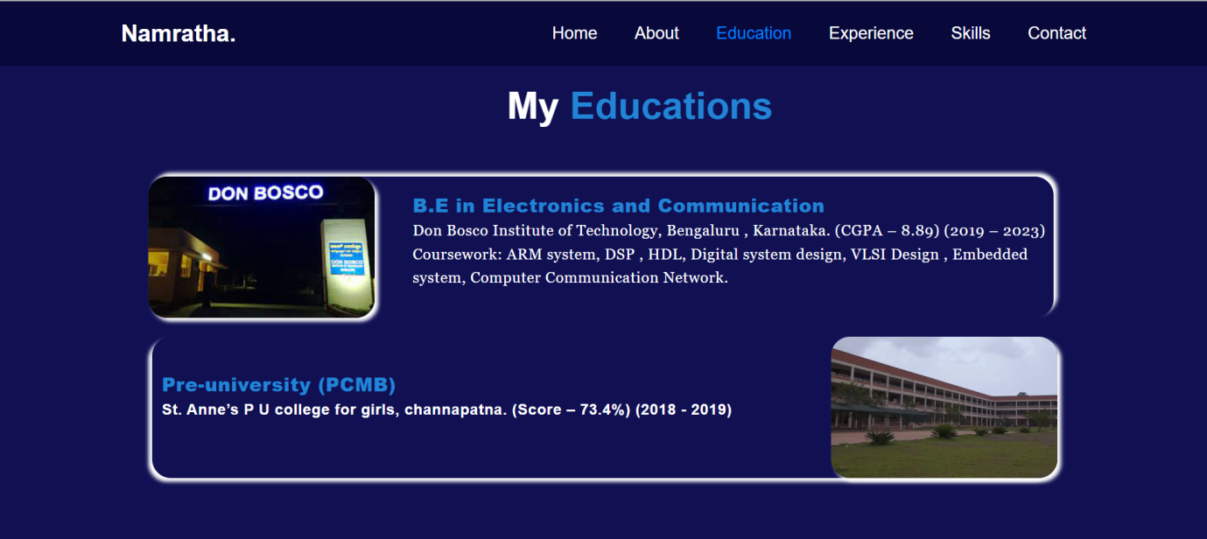
Fig.:3.1

Experience.HTML/ Inline CSS

<!DOCTYPE html>
<html lang="en">
<head>
<meta charset="UTF-8">
<meta http-equiv="X-UA-Compatible" content="IE=edge">
<meta name="viewport" content="width=device-width, initial-scale=1.0">
<title>education</title>
<link href='https://unpkg.com/boxicons@2.1.4/css/boxicons.min.css' rel='stylesheet'>

<style>
*{
margin: 0px;
padding:0px;
box-sizing: border-box;
font-family:sans-serif;
}
body{
color: white;
}
.header{
position: fixed;
top:0px;
left:0px;
width:100%;
padding: 20px 10%;
display: flex;
justify-content: space-between;
align-items: center;
z-index:100;
background:rgb(8, 8, 59);
}
.logo{
font-size:25px;
color:white;
text-decoration: none;
font-weight: 600;
}
.navbar a {
font-size: 18px;
color:white;
text-decoration: none;
font-weight: 500;
margin-left: 35px;
}
.navbar a:hover,
.navbar a.active{
color: rgb(0, 128, 255);
}
.section{
height: 100vh;
display: flex;
align-items: center;

background: rgb(16, 16, 83);
}
.skills{
border: 0px solid white;
align-items: center;
margin-top: -350px;
margin-left: 41%;
font-size: 20px;
width: 25%;
}
.skillsspan1{
color: rgb(33, 132, 213);
font-size: 15px;
}
.d1{
width:33%;
height:150px;
border:0px solid white;
margin-left: -690px;
margin-top: -80px;
border-radius: 20px;
box-shadow: -4px -8px 4px rgb(33, 132, 213);
}
.d2{
margin-left: 100px;
box-shadow: 4px -8px 4px white;
}
.d3{
width:33%;
height: 150px;
border: 0px solid white;
margin-top: 260px;
margin-left: -945px;
border-radius: 20px;
box-shadow: -4px 8px 4px white;
}
.d4{
margin-left: 100px;
box-shadow: 4px 8px 4px rgb(33, 132, 213);

}
p{
font-size: medium;
font-family: Cambria, Cochin, Georgia, Times, 'Times New Roman', serif;
font-weight: 400;
line-height: 30px;
margin-top: 7px;
}
span{
color: rgb(33, 132, 213);
font-weight: 900;
font-size: 15px;
font-family: sans-serif;
}
.btn-box a {
position: relative;
display: inline-flex;
justify-content: center;
align-items: center;
width: 130px;
height: 35px;
background: rgb(0, 110, 255);
border:2px solid rgb(0, 110, 255);
border-radius: 8px;
color: black;
text-decoration: none;
font-weight: 600;
letter-spacing: 1px;
z-index: 1;
overflow: hidden;
transition: .5px;
margin-top: 500px;
margin-left: -550px;
}
.btn-box a:hover {
color:rgb(0, 110, 255);
}
.btn-box a:nth-child(2) {
background: transparent;
color: rgb(0, 110, 255);
}
.btn-box a:nth-child(2):hover{
color: black;
}
.btn-box a:nth-child(2)::before {
background:rgb(0, 110, 255);
}
.btn-box a::before {
content: '' ;
position: absolute;
top: 0;
left: 0;
width: 0;
height: 100%;
background: rgb(8, 8, 59);
z-index: -1;
transition: .5s;
}
.btn-box a:hover:before{
width: 100%;
}
</style>
</head>
<body>
<header class="header">
<a href="#" class="logo">Namratha.</a>
<nav class="navbar">
<a href="home.html" target="_blank" >Home</a>
<a href="About.html" target="_blank">About</a>
<a href="education.html" target="_blank" >Education</a>
<a href="#experience.html" class="active">Experience</a>
<a href="skill.html" target="_blank">Skills</a>
<a href="contact.html" target="_blank">Contact</a>
</nav>
</header>
<div class="section">
<div class="skills">
<h1>My <span style="color: rgb(33, 132, 213); font-size: 40px;">Experience</span></h1>
</div>
<div class="d1"><p><span>Internship at PLUS PPA Nanochip Technologies Private Limited, Bangalore:</span>(01/2023 - 06/2023) <br>PMOS, NMOS, INVERTER, NAND, NOR, Inverter analysis, SRAM basics Design and Analysis of bit cell operation.</p></div>
<div class="d1 d2"><p><span>Internship at Don Bosco Institute of technology on VLSI, Bangalore:</span>(08/2022 - 09/2022)<br>An integrated circuit (IC) is created by combining millions of MOS transistors into a single chip. </p></div>
<div class="d3"><p><span>Internship at maven silicon on VLSI System on chip Design, Bangalore:</span>(01/2023 - 07/2023)<br>The process of creating an integrated circuit (IC) by combining thousands of transistors into a single chip.</p></div>
<div class="d3 d4"><p><span>Intern at Global Quest technology, Bangalore(Ongoing):</span>(07/2023 – 12/2023)<br> A developer or engineer who can build both the front end and the back end of a website.</p></div>
<div class="btn-box">
<a href="certificates.html" target="_blank">Read More</a>
</div>
</div>
</body>
</html>

Output:

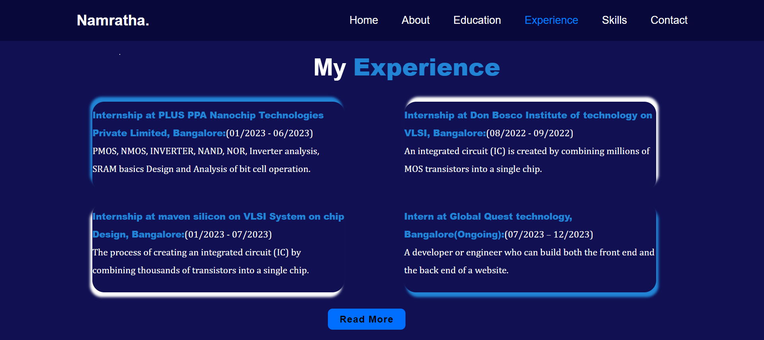
Fig.:4.1

Experience – Read More.HTML/ Inline CSS(Certificates):

<!DOCTYPE html>
<html lang="en">
<head>
<meta charset="UTF-8">
<meta http-equiv="X-UA-Compatible" content="IE=edge">
<meta name="viewport" content="width=device-width, initial-scale=1.0">
<title>Read more</title>
<style>
*{
margin: 0px;
padding: 0px;
}
.whole{
background-color:rgb(8, 8, 59);
height: 570px;
border:1px solid rgb(8, 8, 59); ;
}
h2{
background: transparent;
color: white;
width: 20%;
text-align: center;
margin-left: 550px;
margin-top: 30px;
}
h2 span{
color: rgb(0, 128, 255);
}
.div2{
width: 20%;
height: 350px;
border: 0px solid rgb(0, 128, 255);
margin-top: 70px;
margin-left: 110px;
background: url(internship.jpeg);background-size: cover;box-shadow: -5px -5px 18px rgb(0, 128, 255) ;border-radius: 5px;
}
.div2:hover{
transform: scale(1.1);
transition-property: transform;
transition-duration: .1s,.1s,.1s;
transition-timing-function: linear, linear, linear;
transition-delay: .1s,.1s,.1s;
}
.div3{
width: 31%;
height: 280px;
border: 1px solid rgb(0, 128, 255);
margin-top: -299px;
margin-left: 394px;border-radius: 20px;
background: url(STC.jpeg);background-size: cover;box-shadow: -5px -5px 18px rgb(0, 128, 255) ;
}
.div3:hover{
transform: scale(1.1);
transition-property: transform;
transition-duration: .1s,.1s,.1s;
transition-timing-function: linear, linear, linear;
transition-delay: .1s,.1s,.1s;
}
.div4{
width: 31%;
height: 280px;
border: 1px solid rgb(0, 128, 255);
margin-top: -283px;
margin-left: 820px;border-radius: 20px;
background: url(maven.jpeg);background-size: cover;box-shadow: -5px -5px 18px rgb(0, 128, 255) ;
}
.div4:hover{
transform: scale(1.1);
transition-property: transform;
transition-duration: .1s,.1s,.1s;
transition-timing-function: linear, linear, linear;
transition-delay: .1s,.1s,.1s;
}
</style>
</head>
<body>
<div class="whole">
<div>
<h2>CERTIFICATES</span></h2>
</div>
<div class="div2"></div>
<div class="div3"></div>
<div class="div4"></div>
</div>
</body>

Output:

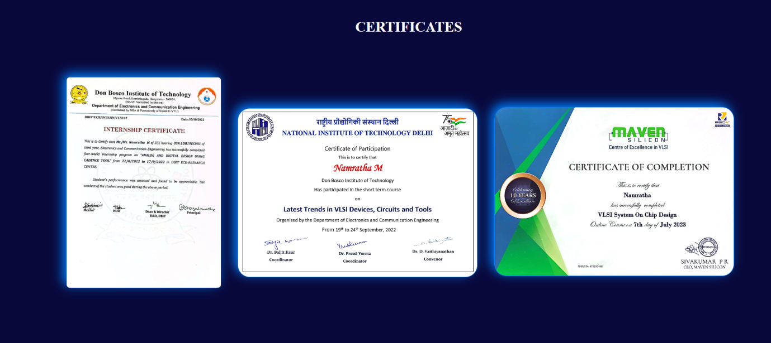
Fig.:4.1.1

Skills.HTML\ Inline CSS

<!DOCTYPE html>
<html lang="en">
<head>
<meta charset="UTF-8">
<meta http-equiv="X-UA-Compatible" content="IE=edge">
<meta name="viewport" content="width=device-width, initial-scale=1.0">
<title>Aboout ME</title>
<style>
*{
margin: 0px;
padding:0px;
box-sizing: border-box;
font-family:sans-serif;
}
body{
color: white;
}
.header{
position: fixed;
top:0px;
left:0px;
width:100%;
padding: 20px 10%;
display: flex;
justify-content: space-between;
align-items: center;
z-index:100;
background:rgb(8, 8, 59);
}
.logo{
font-size:25px;
color:white;
text-decoration: none;
font-weight: 600;
}
.navbar a {
font-size: 18px;
color:white;
text-decoration: none;
font-weight: 500;
margin-left: 35px;
}
.navbar a:hover,
.navbar a.active{
color: rgb(0, 128, 255);
}
.section{
height: 100vh;
display: flex;
align-items: center;
background: rgb(16, 16, 83);
}
.skills{
border: 0px solid white;
align-items: center;
margin-top: -350px;
margin-left: 42%;
font-size: 20px;
width: 50%;
}
.skills span{
color: rgb(33, 132, 213);
}
.d1{
width: 10%;
height: 120px;
background: aliceblue;
margin-left: -1010px;
margin-top: -90px;
background: url(https://logowik.com/content/uploads/images/492_html5.jpg);background-size: cover;background-position: center;border-radius: 20px;
}
.d2{
width: 10%;
height: 120px;
background: aliceblue;
margin-left: 70px;
margin-top: -90px;
background: url(https://i0.wp.com/www.team-ever.com/wp-content/uploads/2014/08/css3.jpg);background-size: cover;background-position: center;
border-radius: 20px;
}
.d3{
width: 10%;
height: 120px;
background: aliceblue;
margin-left: 70px;
margin-top: -90px;
background: url(https://global.discourse-cdn.com/sitepoint/original/3X/e/b/eba3983204f9f9c01dab4c54e33b2b9d9a2731e0.png);background-size: cover;background-position: center;border-radius: 20px;
}
.d4{
width: 10%;
height: 120px;
background: aliceblue;
margin-left: 70px;
margin-top: -90px;
background: url(https://www.brcline.com/wp-content/uploads/2016/01/bootstrap-logo.png);background-size: cover;background-position: center;border-radius: 20px;
}
.d5{
width: 10%;
height: 120px;
background: aliceblue;
margin-left: 70px;
margin-top: -90px;
background: url(https://seeklogo.com/images/M/mysql-logo-B4943FE6DD-seeklogo.com.png);background-size: cover;background-position: center;border-radius: 20px;
}
.d6{
width: 10%;
height: 120px;
background: aliceblue;
margin-left: -120px;
margin-top: 250px;
background: url(https://upload.wikimedia.org/wikipedia/commons/9/94/VLSI_Chip.jpg);background-size: cover;background-position: center;border-radius: 20px;
}
.d7{
width: 10%;
height: 120px;
background: aliceblue;
margin-left: -330px;
margin-top: 250px;
background: url(https://cdn.worldvectorlogo.com/logos/java.svg);background-size: cover;background-position: center;border-radius: 20px;
}
.d8{
width: 10%;
height: 120px;
background: aliceblue;
margin-left: -330px;
margin-top: 250px;
background: url(https://testinggenez.com/wp-content/uploads/2019/11/main-qimg-8b3fecdbd981a0f30b8291cfdbd846c3.png?x69794);background-size: cover;background-position: center;border-radius: 20px;
}
.d9{
width: 10%;
height: 120px;
background: aliceblue;
margin-left: -330px;
margin-top: 250px;
background: url(https://www.freecodecamp.org/news/content/images/2022/07/git-and-github.png);background-size: cover;background-position: center;border-radius: 20px;
}
.d10{
width: 10%;
height: 120px;
background: aliceblue;
margin-left: -330px;
margin-top: 250px;
background: url(https://encrypted-tbn0.gstatic.com/images?q=tbn:ANd9GcTJc6e910MQ1U_loAFTdSj5xYauDUzs7G3Daw&usqp=CAU);background-size: cover;background-position: center;border-radius: 20px;
}
</style>
</head>
<body>
<header class="header">
<a href="#" class="logo">Namratha.</a>
<nav class="navbar">
<a href="home.html" target="_blank" >Home</a>
<a href="About.html" target="_blank" >About</a>
<a href="education.html" target="_blank">Education</a>
<a href="experience.html" target="_blank">Experience</a>
<a href="#skill.html"class="active">Skills</a>
<a href="contact.html" target="_blank">Contact</a>
</nav>
</header>
<div class="section">
<div class="skills">
<h2>My<span> Skills</span></h2>
</div>
<div class="d1"></div>
<div class="d2"></div>
<div class="d3"></div>
<div class="d4"></div>
<div class="d5"></div>
<div class="d6"></div>
<div class="d7"></div>
<div class="d8"></div>
<div class="d9"></div>
<div class="d10"></div>
</div>
</body>
</html>

Output:

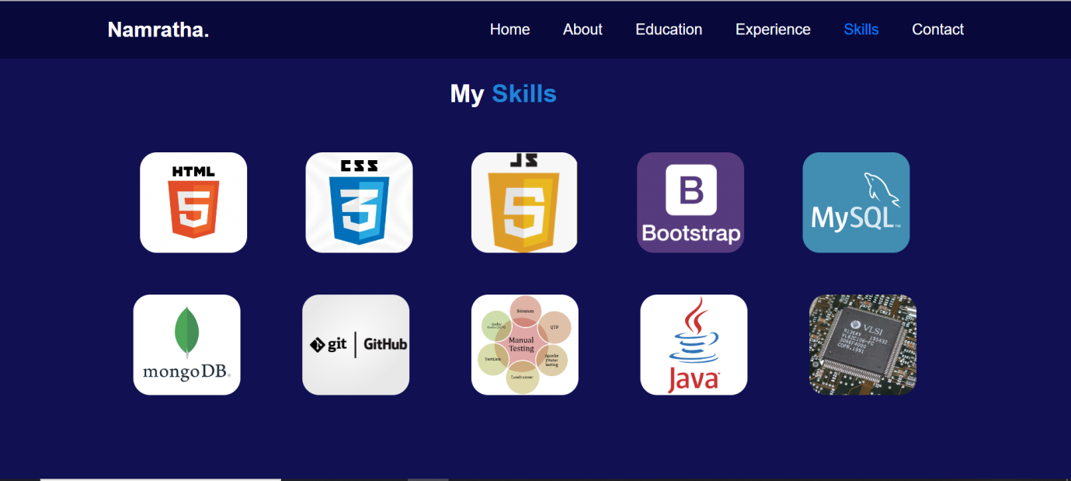
Fig.:5.1

Contact.HTML/ Inline CSS

<!DOCTYPE html>
<html lang="en">
<head>
<meta charset="UTF-8">
<meta http-equiv="X-UA-Compatible" content="IE=edge">
<meta name="viewport" content="width=device-width, initial-scale=1.0">
<title>Contact ME</title>
<link href='https://unpkg.com/boxicons@2.1.4/css/boxicons.min.css' rel='stylesheet'>
<style>
*{
margin: 0px;
padding:0px;
box-sizing: border-box;
font-family:sans-serif;
}
body{
color: white;
}
.header{
position: fixed;
top:0px;
left:0px;
width:100%;
padding: 20px 10%;
display: flex;
justify-content: space-between;
align-items: center;
z-index:100;
background:rgb(8, 8, 59);
}
.logo{
font-size:25px;
color:white;
text-decoration: none;
font-weight: 600;
}

.navbar a {
font-size: 18px;
color:white;
text-decoration: none;
font-weight: 500;
margin-left: 35px;
}
.navbar a:hover,
.navbar a.active{
color: rgb(0, 128, 255);
}
.section1{
height: 100vh;
display: flex;
align-items: center;
width: 50%;
background-color: rgb(158, 191, 235);

}
.section2{
height: 100vh;
display: flex;
align-items: center;
width: 50%;
background-color: rgb(16, 16, 83);
margin-left: 50%;
margin-top: -572px;
}
.section1 div{
width: 20%;
height: 40px;
border: 0Spx solid blue;
margin-top: -160px;
margin-left: 20%;
}
.section1 div h2{
color:rgb(16, 16, 83) ;
font-family:Verdana, Geneva, Tahoma, sans-serif;
}
.section1 div p{
width: 300%;
height: 40px;
border: 0px solid black;
margin-top: 30px;
line-height: 20px;
color: rgb(74, 74, 178);
}

#id2{
width: 40%;
height: 30px;
border: 0px solid white;
margin-top: -40%;
margin-left: 30px;
}
#id3{
border: 0px solid white;
width: 450px;
height: 250px;
margin-top: 100px;
margin-left: -250px;
}
#id3 input{
height: 30px;
width: 100%;
background-color: white;
}
#id1{
width: 30%;
height: 40px;
border: 0px solid blue;
margin-top: 120px;
margin-left: -130px;
}
#id1 div{
width: 150%;
height: 40px;
border: 0px solid blue;
margin-top: 30px;
margin-left: 0px;
}
#id1 i{
font-size: 37px;
color: rgb(74, 74, 178);
}
.btn-box a {
position: relative;
display: inline-flex;
justify-content: center;
align-items: center;
width: 120px;
height: 35px;
background: rgb(0, 110, 255);
border:2px solid rgb(0, 110, 255);
border-radius: 8px;
color: black;
text-decoration: none;
font-weight: 600;
letter-spacing: 1px;
z-index: 1;
overflow: hidden;
transition: .5px;
margin-left: -100px;
margin-top: 450px;
}
.btn-box a:hover {
color:rgb(0, 110, 255);
}
.btn-box a:nth-child(2) {
background: transparent;
color: rgb(0, 110, 255);
}
.btn-box a:nth-child(2):hover{
color: black;
}
.btn-box a:nth-child(2)::before {
background:rgb(0, 110, 255);
}
.btn-box a::before {
content: '' ;
position: absolute;
top: 0;
left: 0;
width: 0;
height: 100%;
background: rgb(8, 8, 59);
z-index: -1;
transition: .5s;
}
.btn-box a:hover:before{
width: 100%;
}
</style>
</head>
<body>
<header class="header">
<a href="#" class="logo">Namratha.</a>
<nav class="navbar">
<a href="home.html" target="_blank" >Home</a>
<a href="About.html" target="_blank">About</a>
<a href="education.html" target="_blank">Education</a>
<a href="experience.html" target="_blank">Experience</a>
<a href="skill.html" target="_blank">Skills</a>
<a href="#contact.html" class="active">Contact</a>
</nav>
</header>
<div class="section1">
<div> <h2>LOCATION</h2>
<p>flat no.203 SLNS tower 2 mountview enclave, Vidyanagar cross Airport road,banglore north-562157</p>
</div>
<div id="id1"><h2> FOLLOW US </h2>
<div>
<a href=""><i class='bx bxl-linkedin-square'></i></a>
<a href=""><i class='bx bxl-instagram-alt' ></i></a>
<a href=""><i class='bx bxl-facebook-square'></i></a>
<a href=""><i class='bx bxs-envelope' ></i></a>
<a href=""><i class='bx bxl-google-plus-circle' ></i></a>
</div>
</div>
</div>
<div class="section2"><div id="id2"> <h2>CONTACT FORM</h2></div>
<div id="id3">
<input type="text" id="text" placeholder="Enter your Name">
<input type="email" id="email" placeholder="Enter a valid email address" style="margin-top: 15px;">
<input type="email" id="email" placeholder="Enter your message" style="margin-top: 15px;height: 150px;">
</div>
<div class="btn-box">
<a href="#">Submit</a>
</div>
</div>
</body>
</html>
Output:

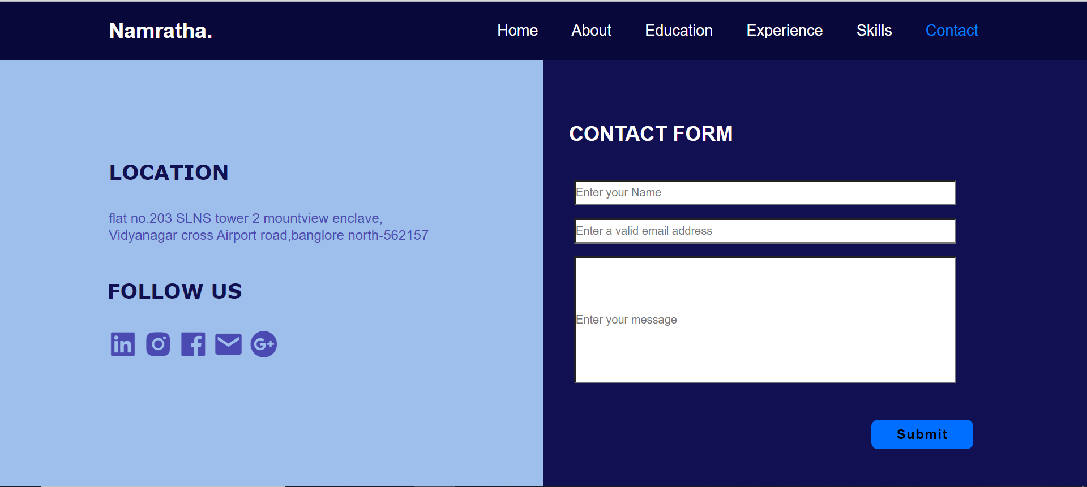
Fig.:6.1

Conclusion
In conclusion, the development of a portfolio using only HTML and CSS demonstrates the power of simplicity and the skilful utilization of fundamental web technologies. This project exemplifies the effectiveness of clean and well-structured code to replicate the core features and design of the original website.
By leveraging HTML for structuring content and CSS for styling, we have achieved a faithful representation of the portfolio and layout. This approach underscores the importance of attention to detail in design and the mastery of these fundamental web technologies.
In summary, the successful creation of a portofolio using only HTML and CSS showcases the importance of these foundational technologies in web development and their capability to replicate a website's design and layout with precision.

